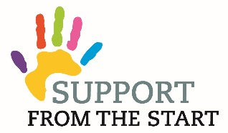

Support from the Start / First Thousand and One Days Family Worker (for Dunbar Cluster)
Salary - £25,549 (pro rata for 25 hours)
Location – based at Dunbar Medical Centre
Hours - 25 hours - Flexibility will be required
Do you want to make a difference to the lives of children and families?
We are seeking to appoint a Family Worker who will be dedicated to help children and families from conception until age 2 in the communities of Dunbar to get the best start in life. We seek someone who demonstrates compassion and empathy with families and can offer support to help them access local services. Building positive relationships and confidence is essential especially within the family, schools, local community and with health professionals. The Family Worker will work across Dunbar. The overarching aim of this post is to raise attainment of children by improving parental engagement in learning.
You will be self-motivated, enthusiastic, approachable, organised and committed.
Applicants must hold relevant qualifications in working with children and families.
A full job description and application form is available on our website www.carefreekidseastlothian.org contact (01875) 613133. The post is funded through Dunbar Area Partnership until March 2020 in the first instance. Funding options for sustaining the post are being explored with a wide range of funders and partners. The post will be managed on behalf of Support from the Start by Carefree Kids with supervision from a steering group of Dunbar professionals.
Carefree Kids is an East Lothian children’s charity and aims to be inclusive to all members of the local community and works closely with like minded partners providing community nutrition support, sports and community development and access to volunteer development.

Closing date for completed application forms is Midday - Friday, 28th September 2018.
Interviews will be held on 10th October.

