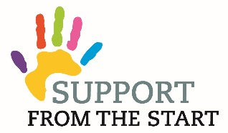

Support from the Start Family Worker
(for Haddington Cluster)

Salary - £25,549 pro rata
Location – based at Newtonport Medical Centre, Haddington
Hours - 21 hours - flexibility will be required
Do you want to make a difference to the lives of children and families?
We are seeking to appoint a Family Worker who will be dedicated to help children and families from conception until age 8 in the communities of Haddington to get the best start in life. We seek someone who demonstrates compassion and empathy with families and can offer support to help them access local services. Building positive relationships and confidence is essential especially within the family, schools, local community and with health professionals. The Family Worker will work across Haddington. The overarching aim of this post is to raise attainment of children by improving parental engagement in learning.
You will be self-motivated, enthusiastic, approachable, organised and committed.
Applicants must hold relevant qualifications in working with children and families.
A full job description and application form is available on our website www.carefreekidseastlothian.org or by contacting 01875 613133. The post is funded through Haddington & Lammermuir Area Partnership until May 2020 in the first instance. We are working on ways to sustain the posts in the longer term. The post will be managed on behalf of Support from the Start by Carefree Kids East Lothian with supervision from a steering group of Haddington professionals.
Carefree Kids East Lothian is an East Lothian children’s charity and aims to be inclusive to all members of the local community and works closely with like minded partners providing community nutrition support, sports and community development and access to volunteer development.
Closing date for completed application forms is Thursday 6th June 2019 (midday).
Interviews will be held on 13th June 2019.

